**AD3002 – HEALTHCARE ANALYTICS**

**MINI PROJECT**

**Project Title: Predictive Analysis for Liver Disease**

**Introduction:**

This project focuses on the application of machine learning and deep learning techniques to predict liver disease based on various patient attributes. The goal is to develop a predictive model that can assist in early detection and intervention for individuals at risk of liver disease.

**Problem Statement:**

Liver disease is a major public health concern, and early detection is crucial for effective intervention and treatment. Manual prediction of liver disease based on individual attributes is time-consuming and subject to human error. This project addresses the need for an accurate and automated liver disease prediction system using machine learning and deep learning, with the goal of improving healthcare outcomes and resource allocation.

**Project Steps:**

**Data Collection:**

Gather a comprehensive dataset containing relevant patient attributes such as age, gender, bilirubin levels, albumin levels, alcohol consumption, and liver disease status.

**Exploratory Data Analysis (EDA):**

Perform EDA to understand the dataset, including data distribution, summary statistics, and potential relationships between variables. Visualize data using plots and charts to gain insights into the dataset's characteristics.

**Data Preprocessing:**

Handle missing data by imputing or removing incomplete records. Identify and address outliers that could adversely affect model performance.

**Data Splitting:**

Split the dataset into training and testing sets for model evaluation. Ensure a proper balance between the two sets to prevent data leakage.

**Data Standardization:**

Standardize numerical features to bring them to a common scale. This step is essential to ensure that all features contribute equally to the model.

**Model Selection and Training:**

Choose machine learning algorithms suitable for binary classification problems. Gradient Boosting and Neural Networks are strong contenders.

**Model Evaluation:**

Evaluate the models' performance using metrics like accuracy, precision, recall, F1-score, and ROC-AUC.

**Hyperparameter Tuning:**

Fine-tune hyperparameters of the selected model to enhance its predictive power. Use techniques like grid search or random search for optimization.

**Model Testing:**

Use the testing dataset to assess the model's generalization to unseen data. Evaluate its performance and report key metrics.

**Implementation:**

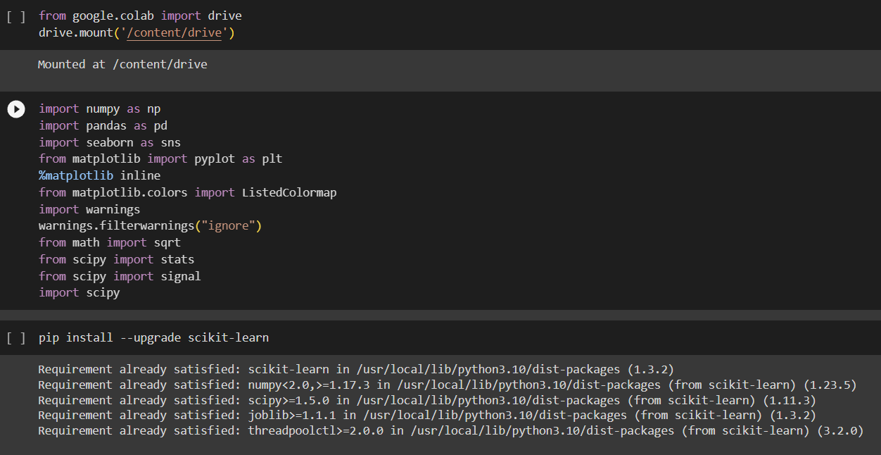

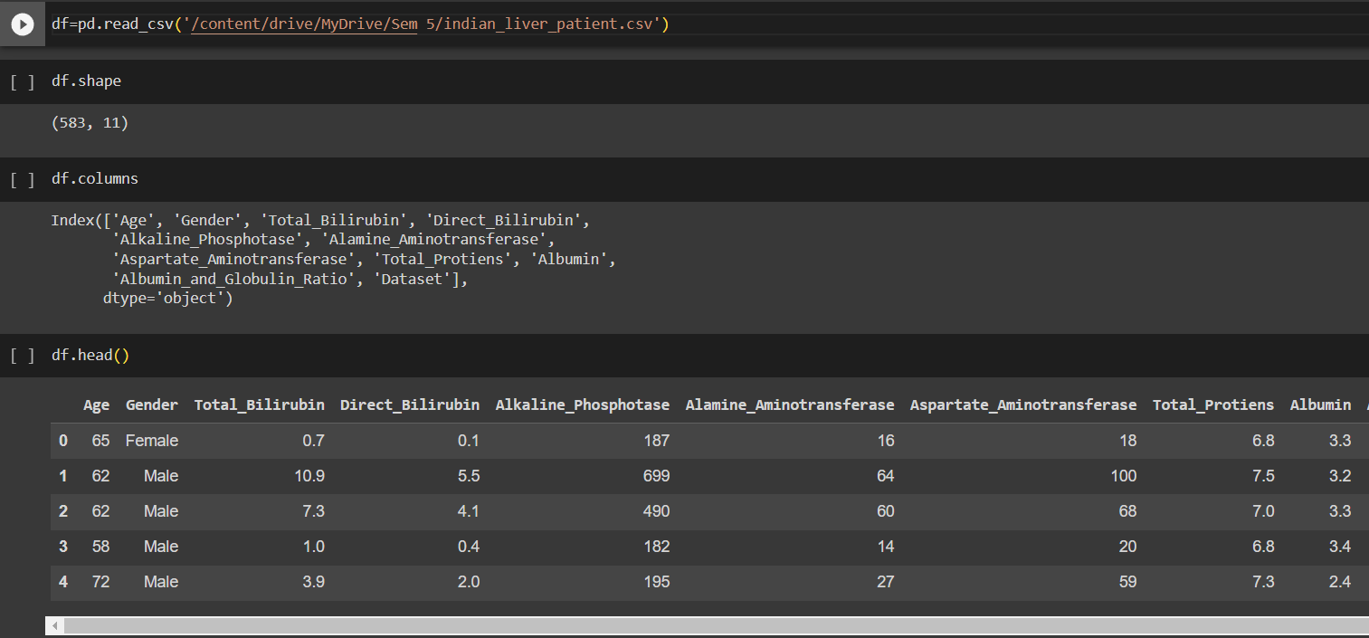

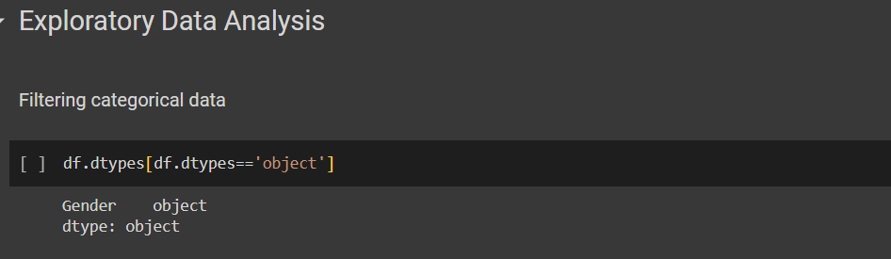

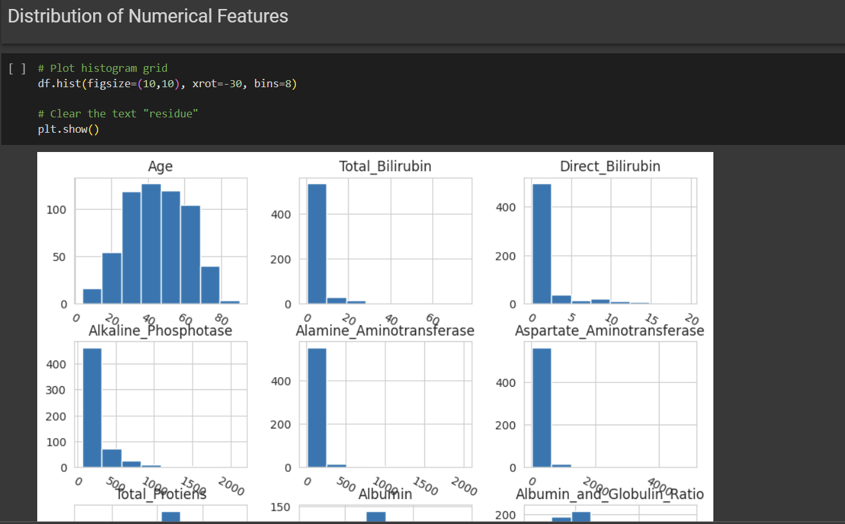

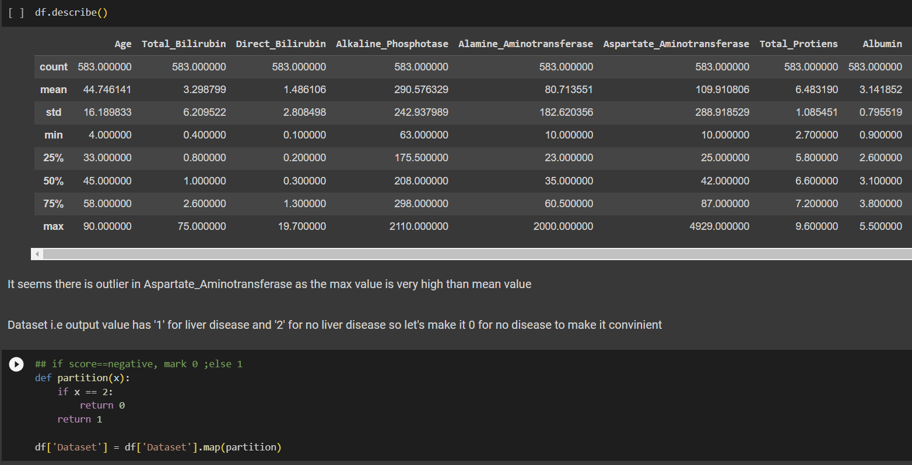

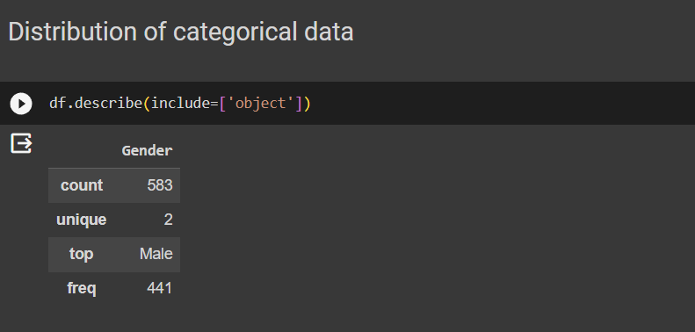

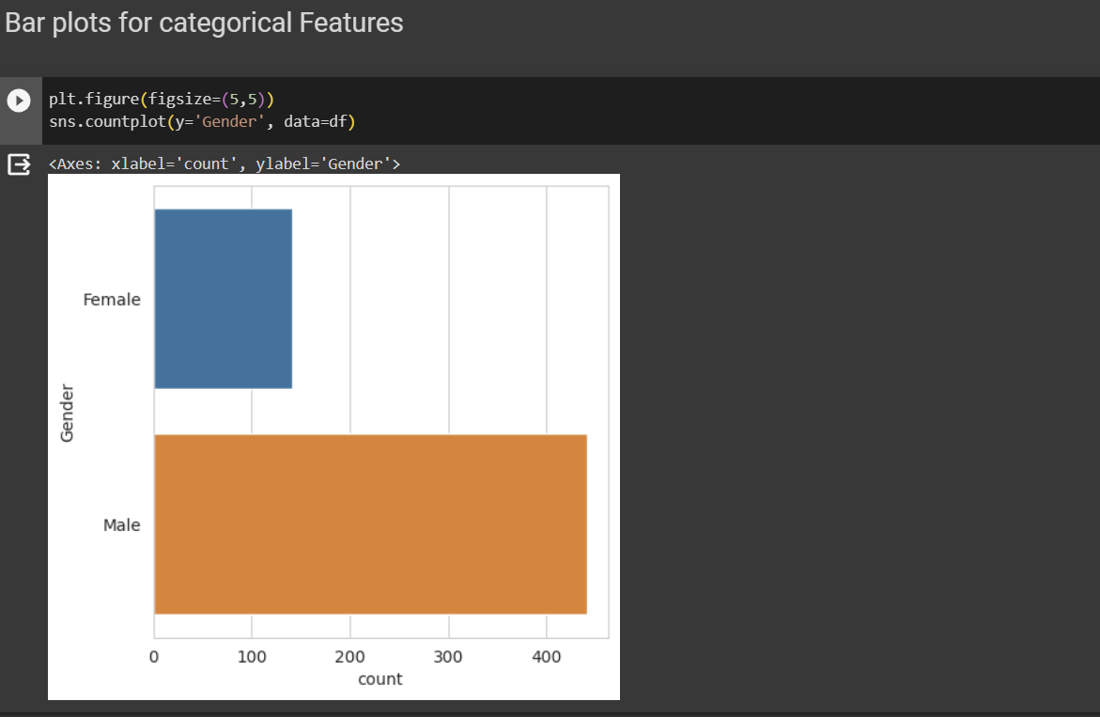

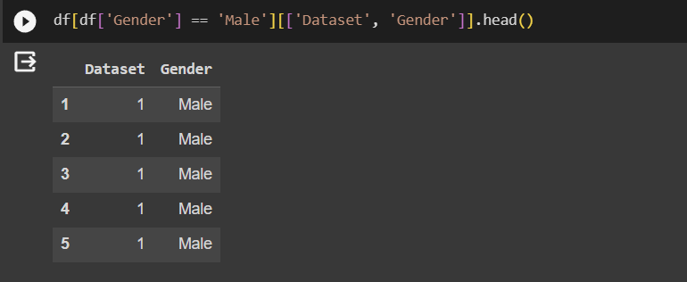

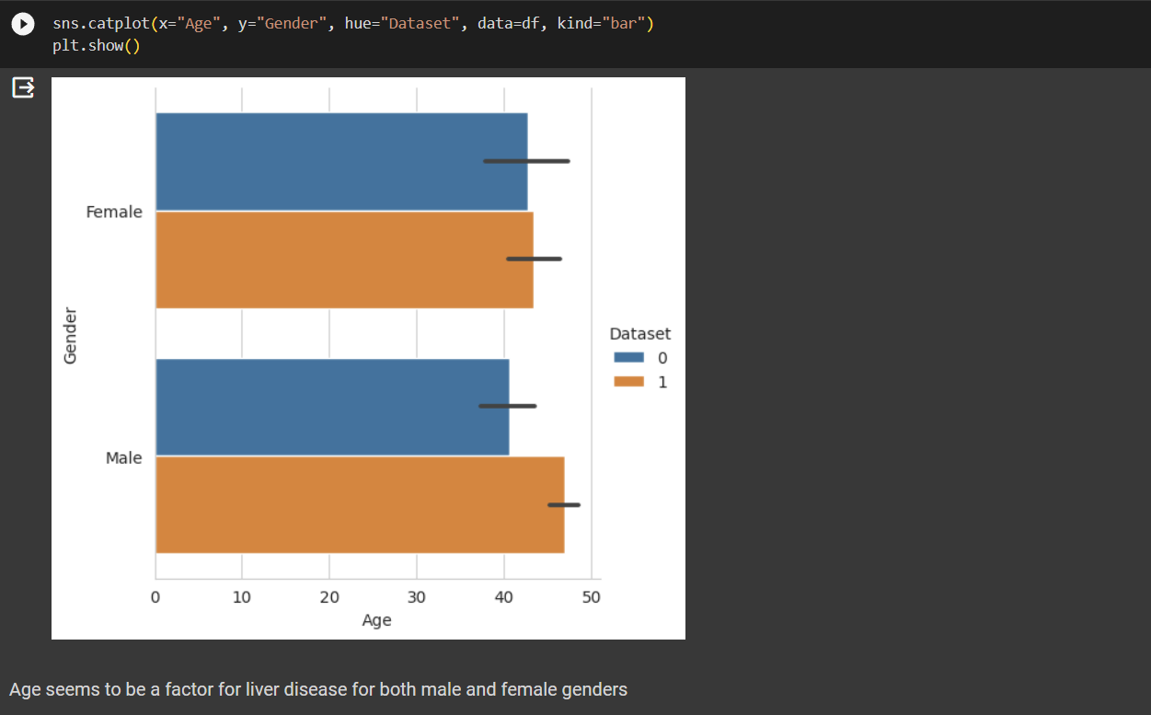

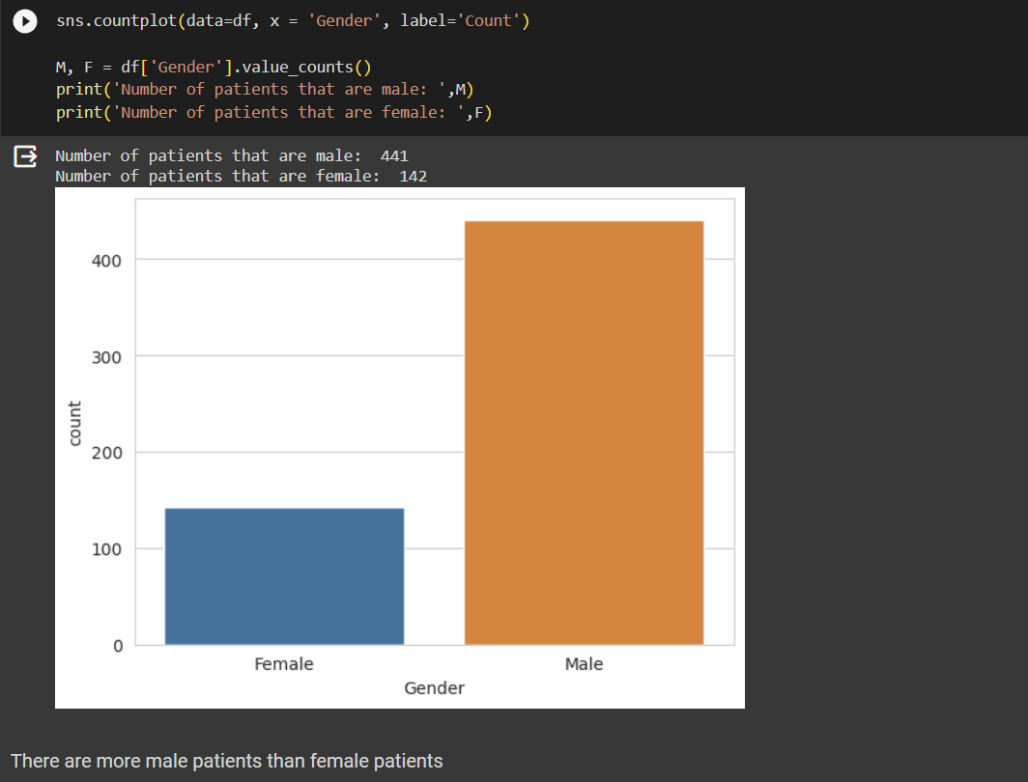

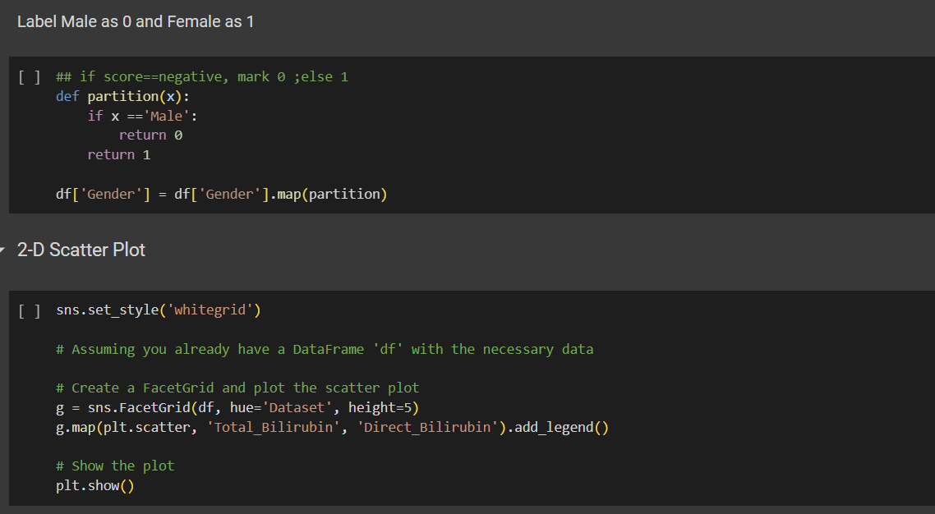

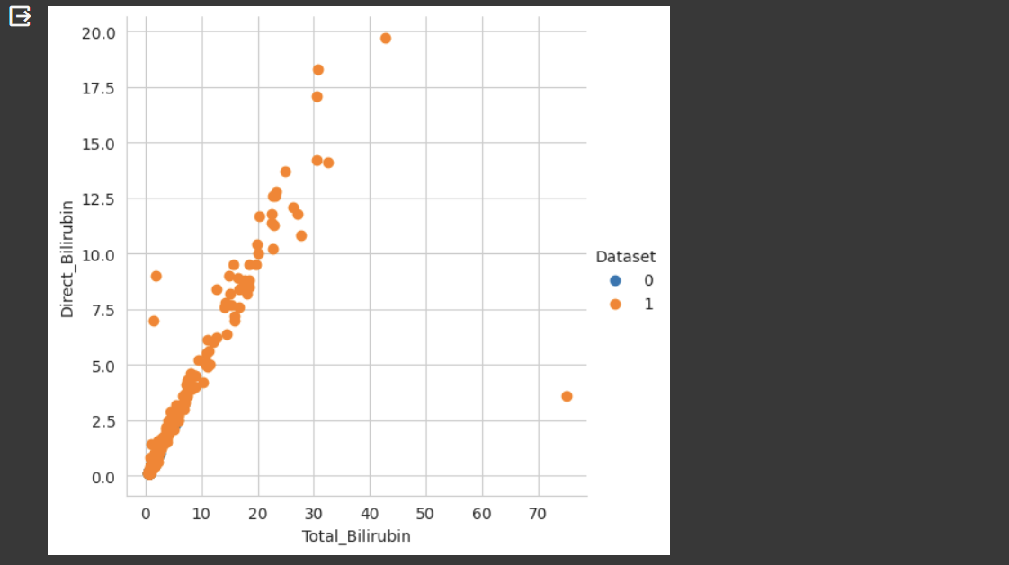

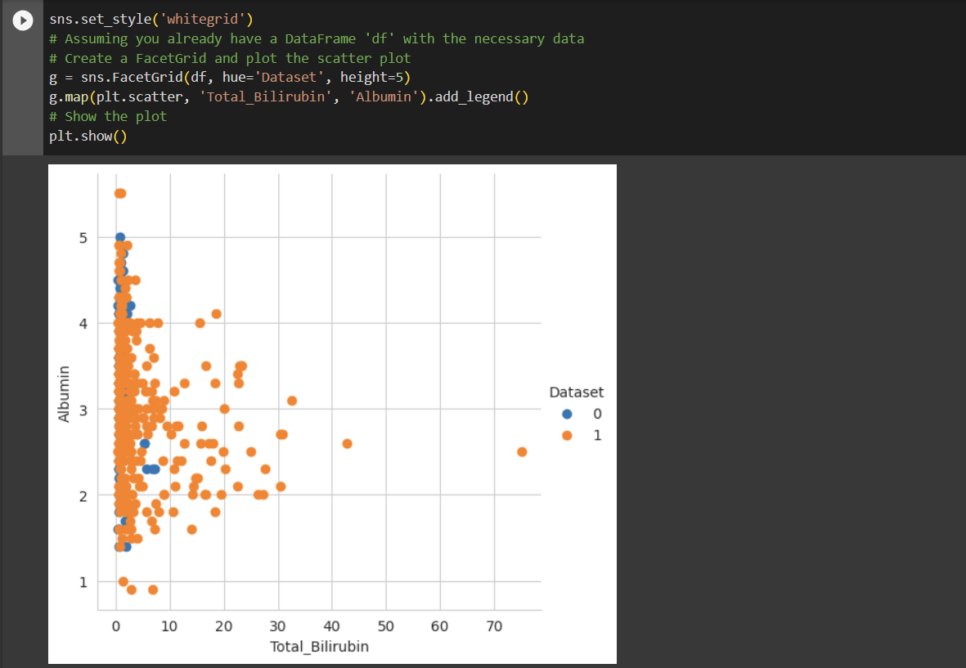

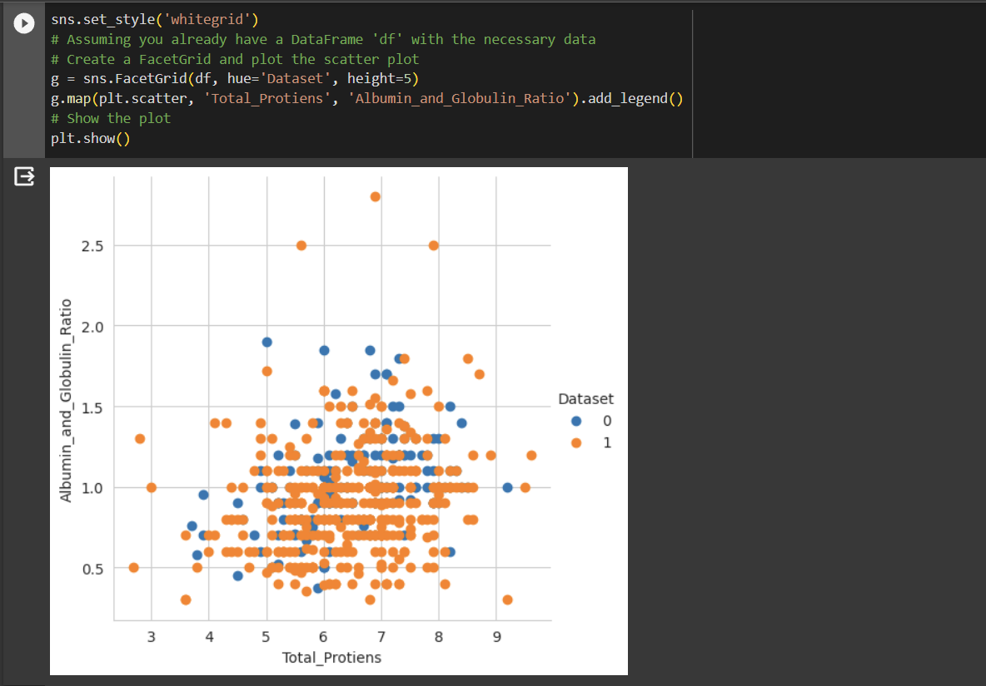

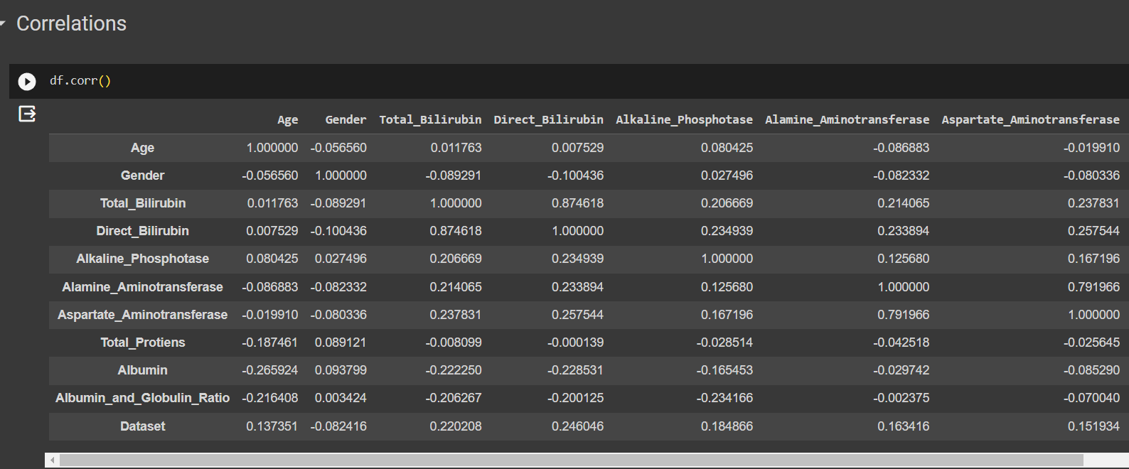

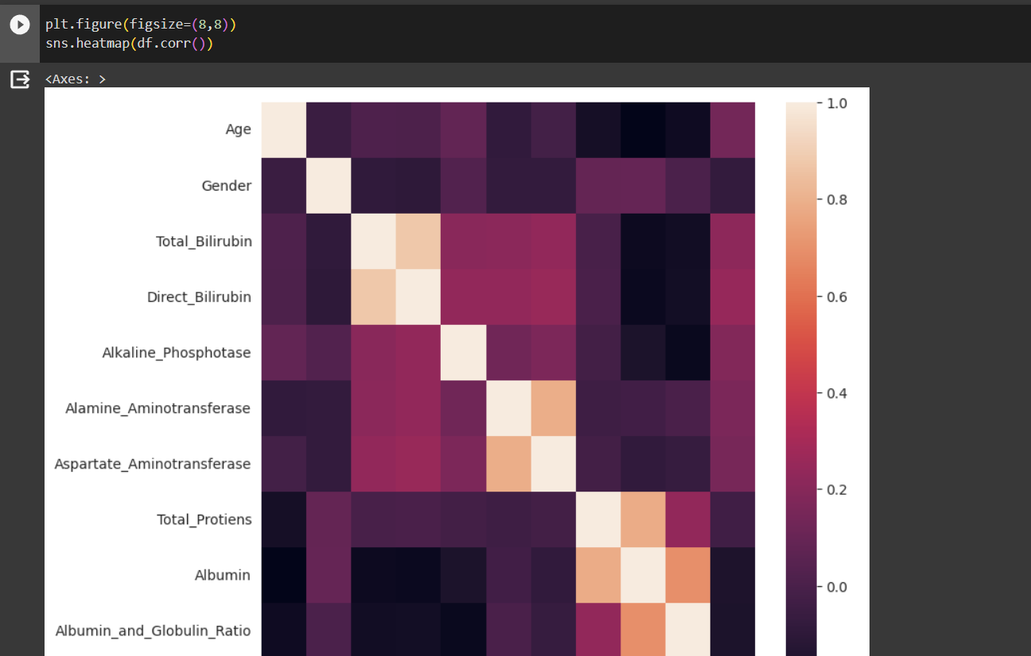

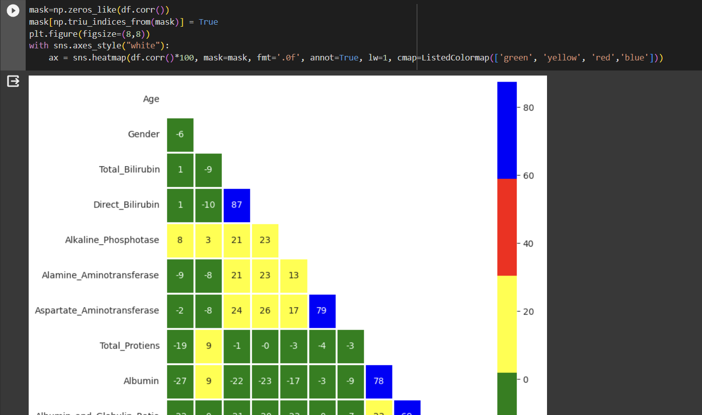

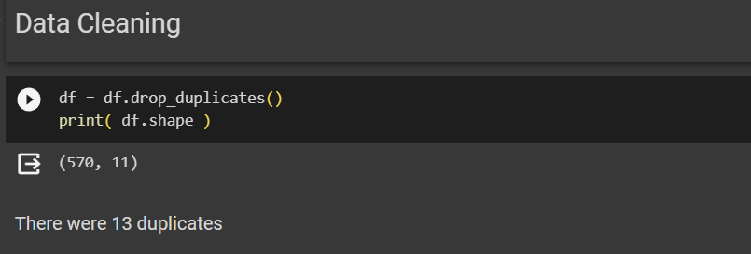

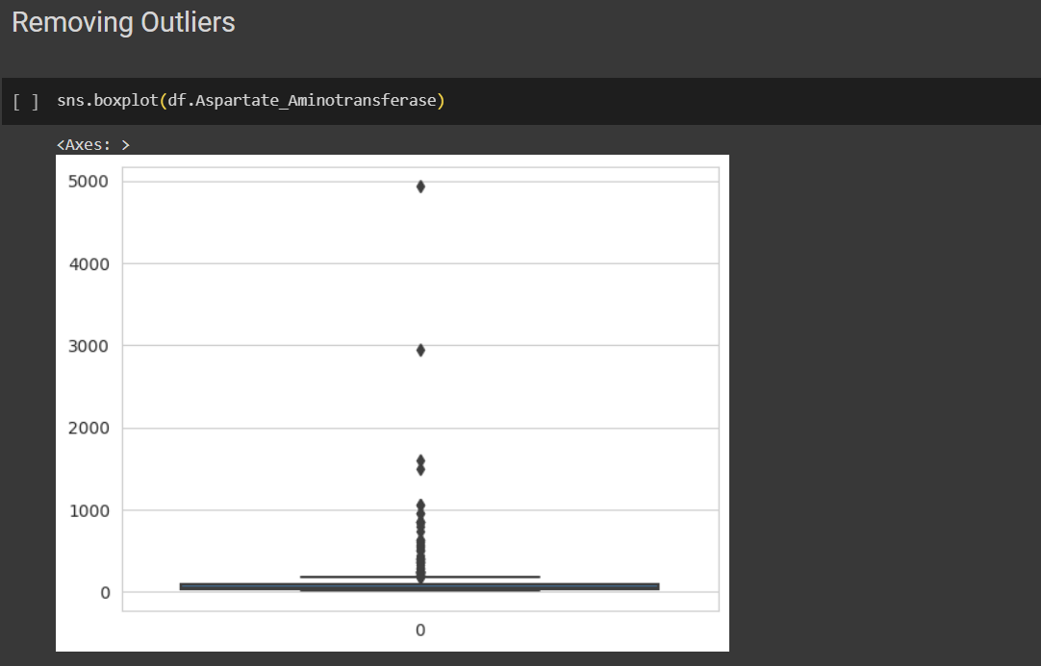

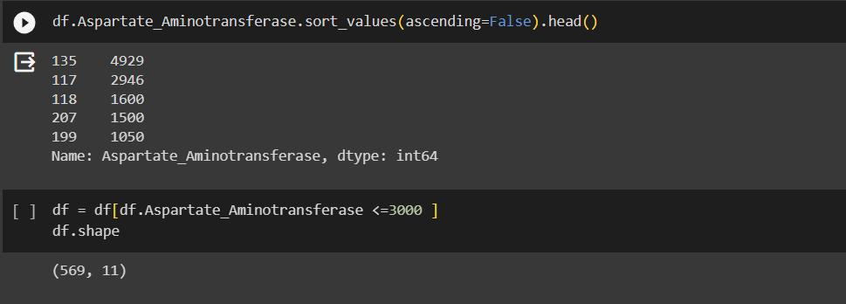

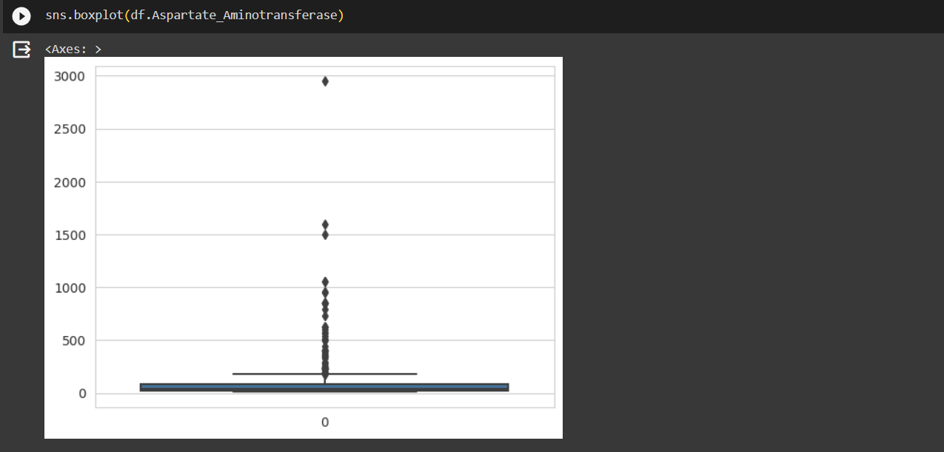

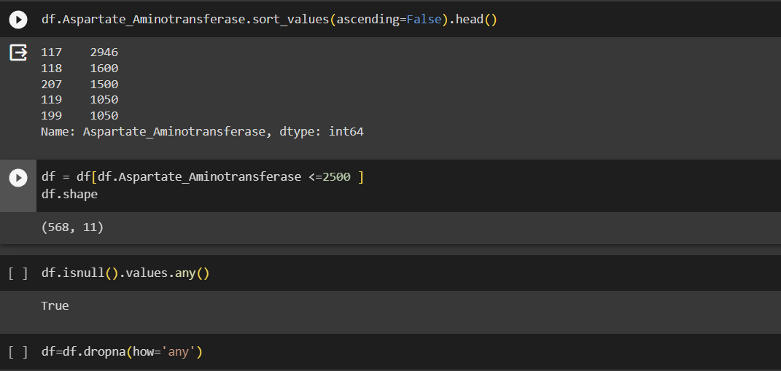

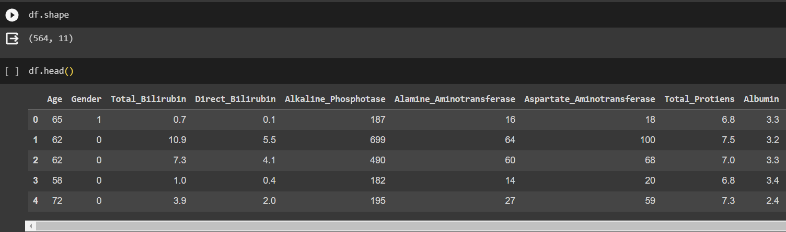

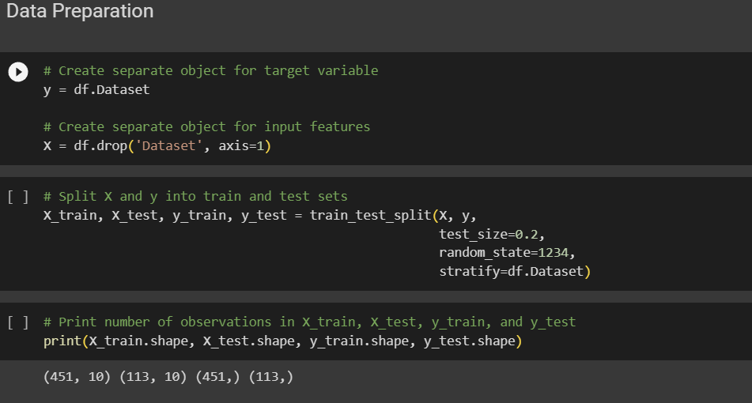

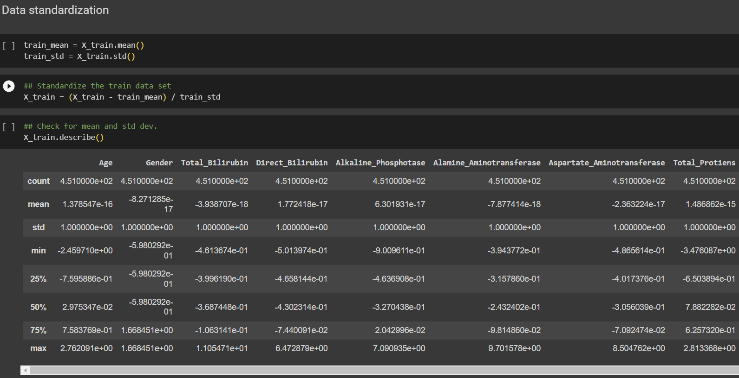

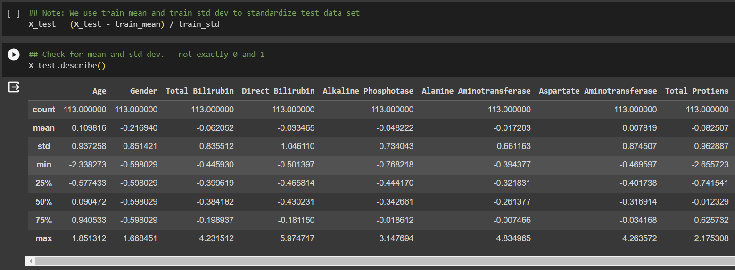

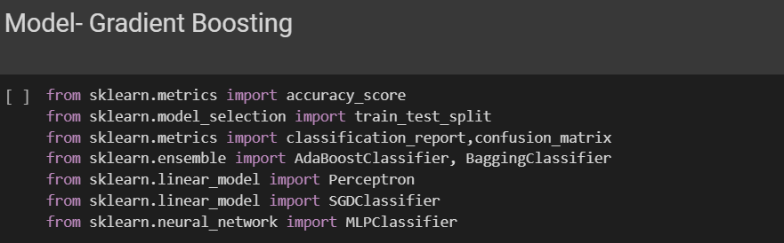

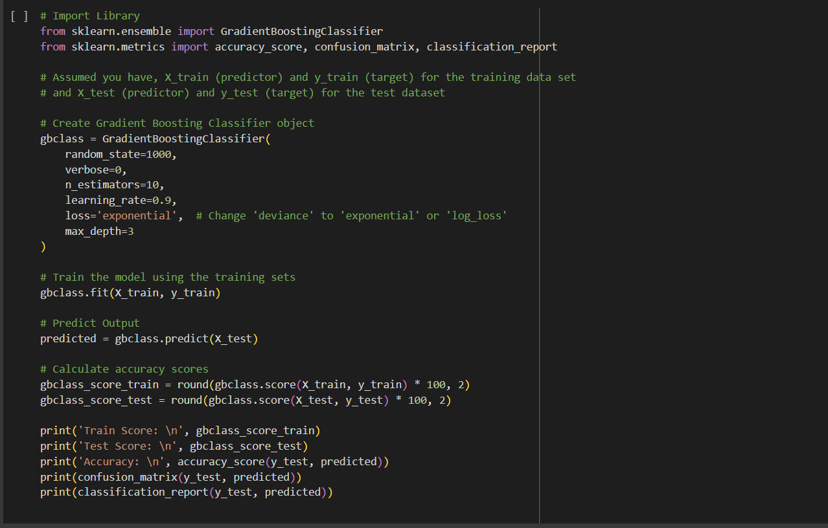

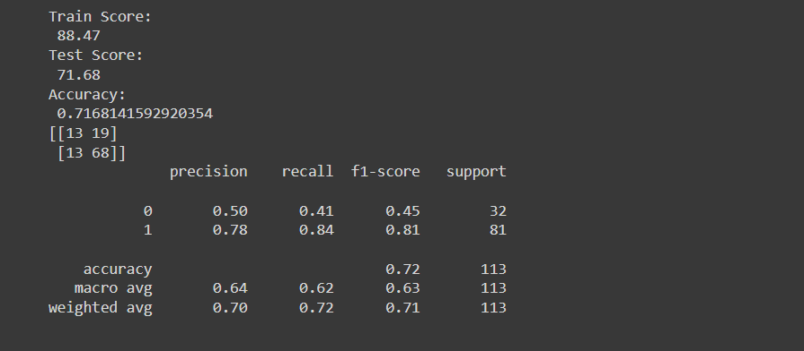

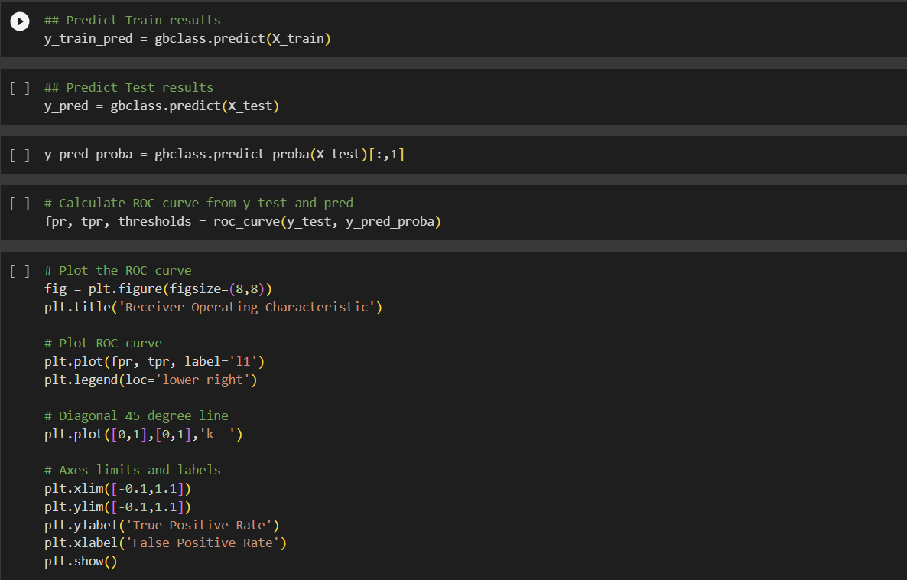

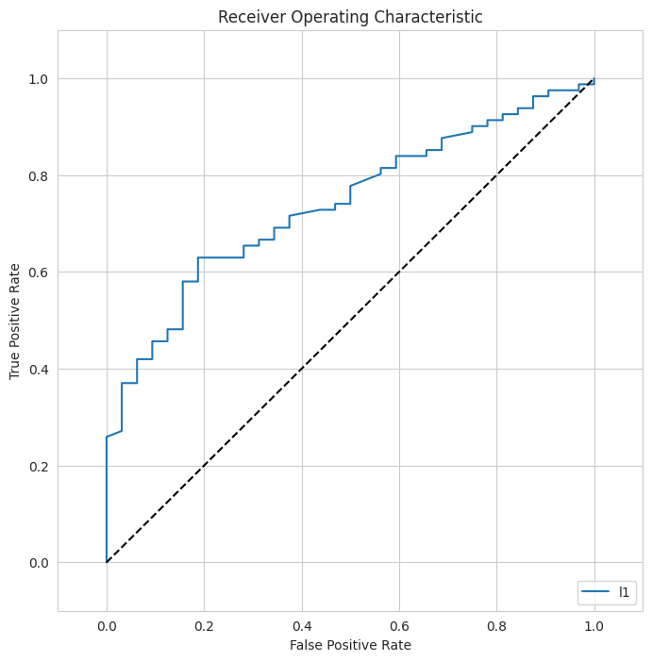

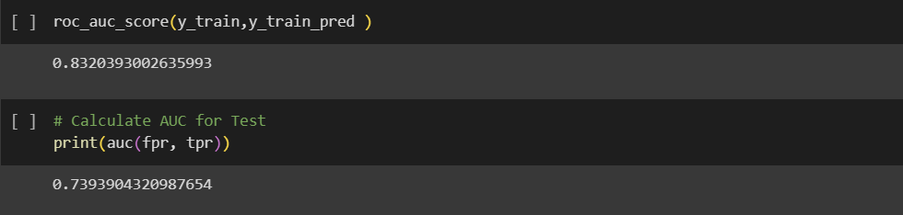

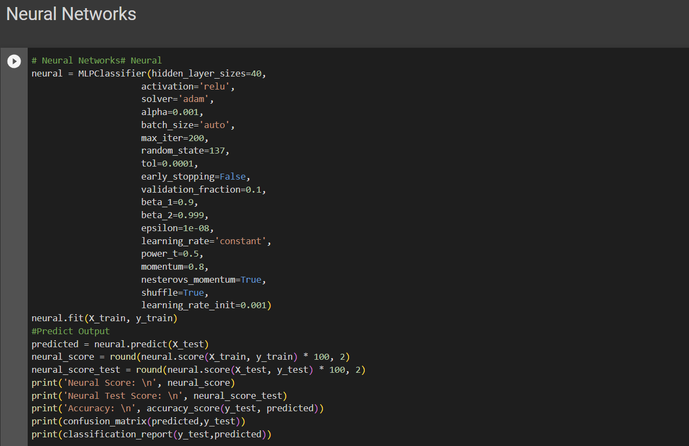

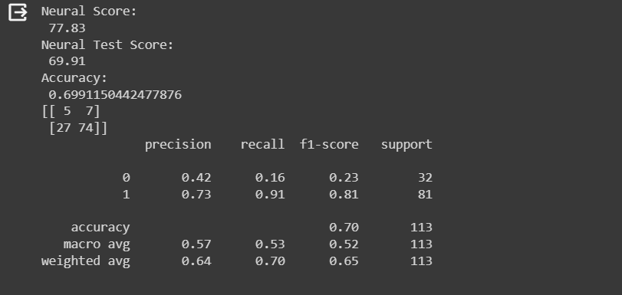

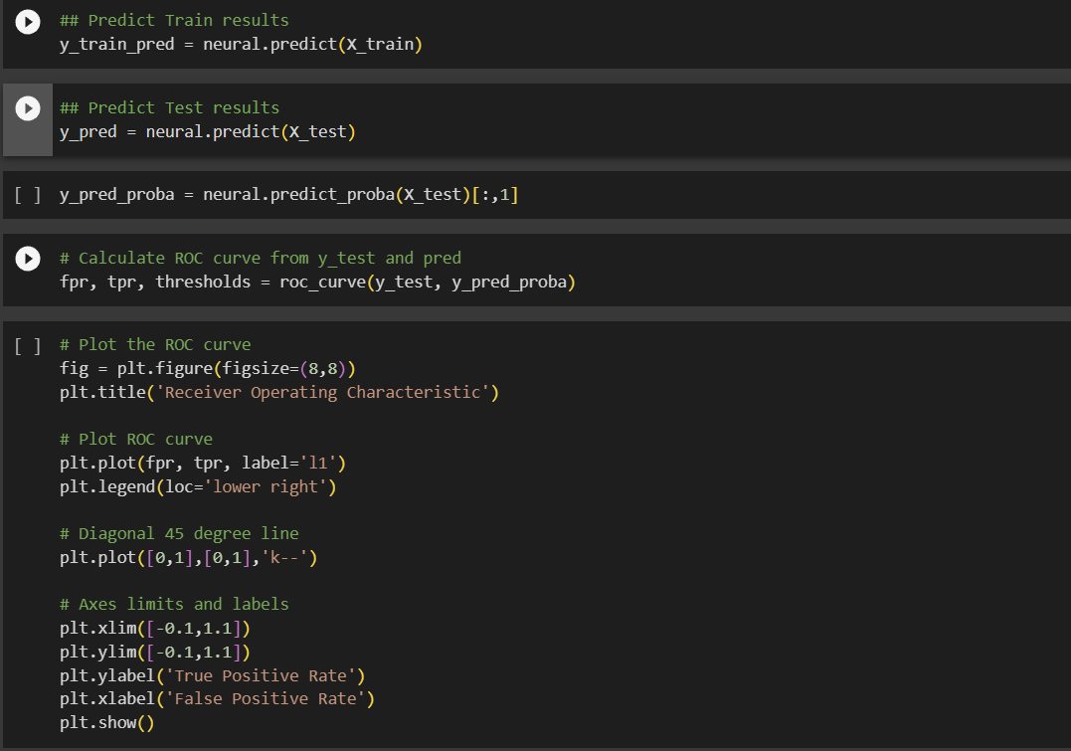

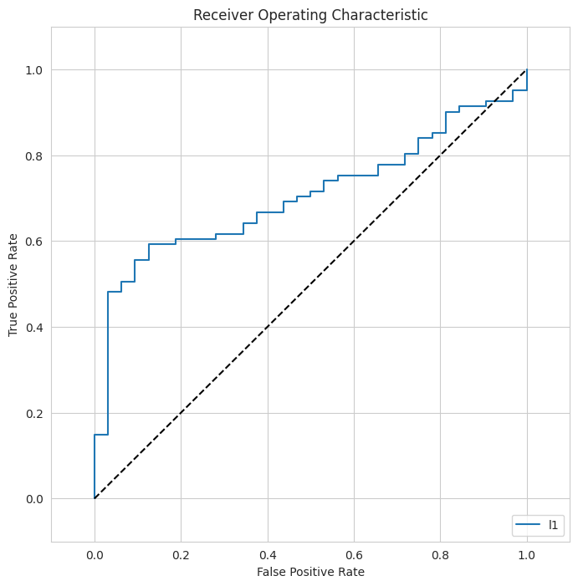

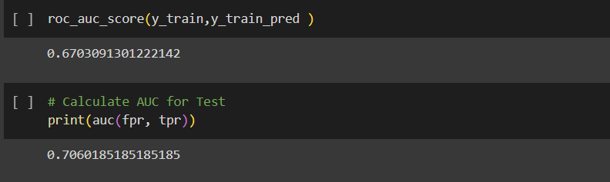

**Conclusion:**

The liver disease prediction project successfully explored and analyzed a dataset of medical records, preprocessed data, and employed machine learning models to predict the likelihood of liver disease in individuals. The Gradient Boosting model and Neural Networks demonstrated promising results in terms of accuracy and predictive power.

This project holds significant potential for healthcare applications, as early detection of liver disease can lead to timely medical interventions. Moreover, it showcases the importance of data-driven approaches in modern healthcare, where predictive modeling can aid medical practitioners in making informed decisions for patient care.